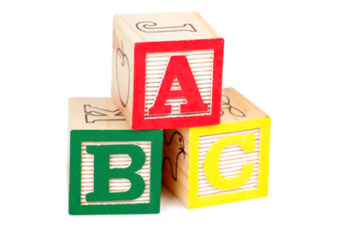BARCOMBE PLAYGROUP

Accidents and Emergencies

Most children will have occasional falls and minor accidents at some point during their time in Playgroup. Whilst staff will take all reasonable steps to ensure that hazards to children – both indoors and outdoors – are kept to a minimum, we recognise that children need to explore and test their own developing physical abilities and may therefore occasionally injure themselves. When such an accident occurs staff will:

- Comfort the Child and provide any necessary first aid treatment.

- Record details of what happened in the accident book including any treatment given.

- Sign two copies in the accident book and ensure that whoever collects the child also signs it and takes a copy.

- Bring the accident to the notice of the manager who will consider any changes which need to be made to nursery equipment or routines etc. in order to prevent the same accident happening to another child.

We keep an appropriately stocked first aid box on the premises.

In the extremely rare event that your child needs hospital treatment we will contact you immediately and arrange to meet you at the hospital. Your child will be transported by ambulance or taxi at our expense and the child’s key person or another member of staff will travel with them.

We will notify Ofsted and the local child protection agency as soon as possible and in any case within 14 days, of any serious accident or injury to, or serious illness of any child whilst in our care and act on any advice given.

At least one member of staff who has a current paediatric first aid certificate will be on the premises at all times when children are present and also on any outings.

